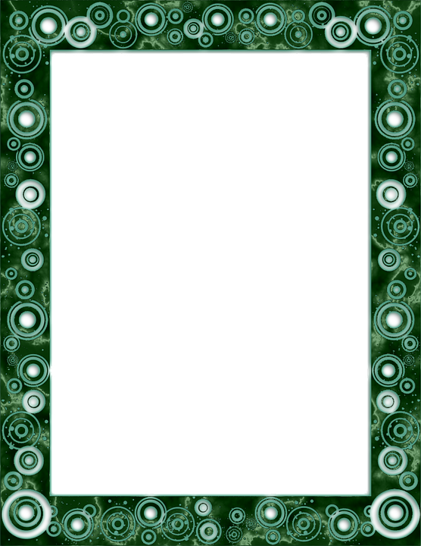

Covid-19 Time Capsule

Life is filled with events that have such a strong impact on our emotions, that we have a better chance of remembering the feelings associated with the event.

Even still, when we think back to some of our most important days in our lives – maybe the first day of school, or the first time we scored a goal in soccer, or when we met our best friend, our memory may not be as sharp as we hope.

The entire world is going through this unique time in history together. It will most certainly become a significant part of our history. For years to come, people will talk about the Corona Virus time period and questions will arise like-

“What did you do during that time?”

“What were you feeling?”

“What was it like?”

Since memory really isn’t as reliable as we wish it were, it might be good to write down your experience. Natalie Long, a mom & graphic designer from Cananda, created time- capsule worksheets for her daughter to document this memorable event. The 11 page document consists of various activities like parent interviews, favorite foods, and a letter written to yourself.

Time-capsules are often buried in a special spot to be uncovered years later. Or sometimes, they are just kept in special spot in a home. Some people even make their time-capsule into a video instead of placing objects in a box. Whatever it is you decide to do, be creative. Use ALL of your senses to decide what will be a part of your memory.